**OUTPUT**

**SCREEN SHOT-01**

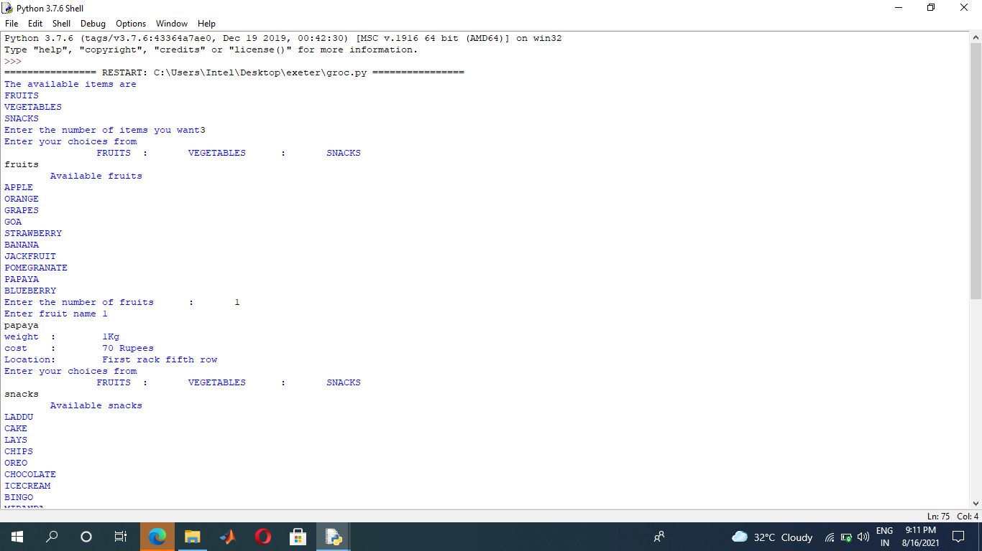

**SCREEN SHOT-02**

